# React.js Project Report – LearnScape

Submitted by: Varad Vikas Mandhare  
MIT ADT University, Pune

## Assignment 1: React App Setup & Navigation

Aim:  
To design and implement assignment 1: react app setup & navigation using React.js.

Theory:  
React.js provides a component-based architecture that simplifies the development of modern web applications. Each component manages its own state and renders efficiently when the underlying data changes. This modularity ensures better reusability, scalability, and maintainability of code. In this assignment, React concepts such as JSX, functional components, hooks (useState, useEffect), and props are utilized to achieve desired functionality.  
  
React promotes a declarative approach where the UI automatically updates when data changes. By leveraging Virtual DOM and efficient diffing algorithms, React minimizes DOM manipulation and improves performance. The assignment demonstrates how component-driven development enhances productivity and consistency across the LearnScape project.

Code:  
Sample code and component structure implemented using ReactJS.

Output:

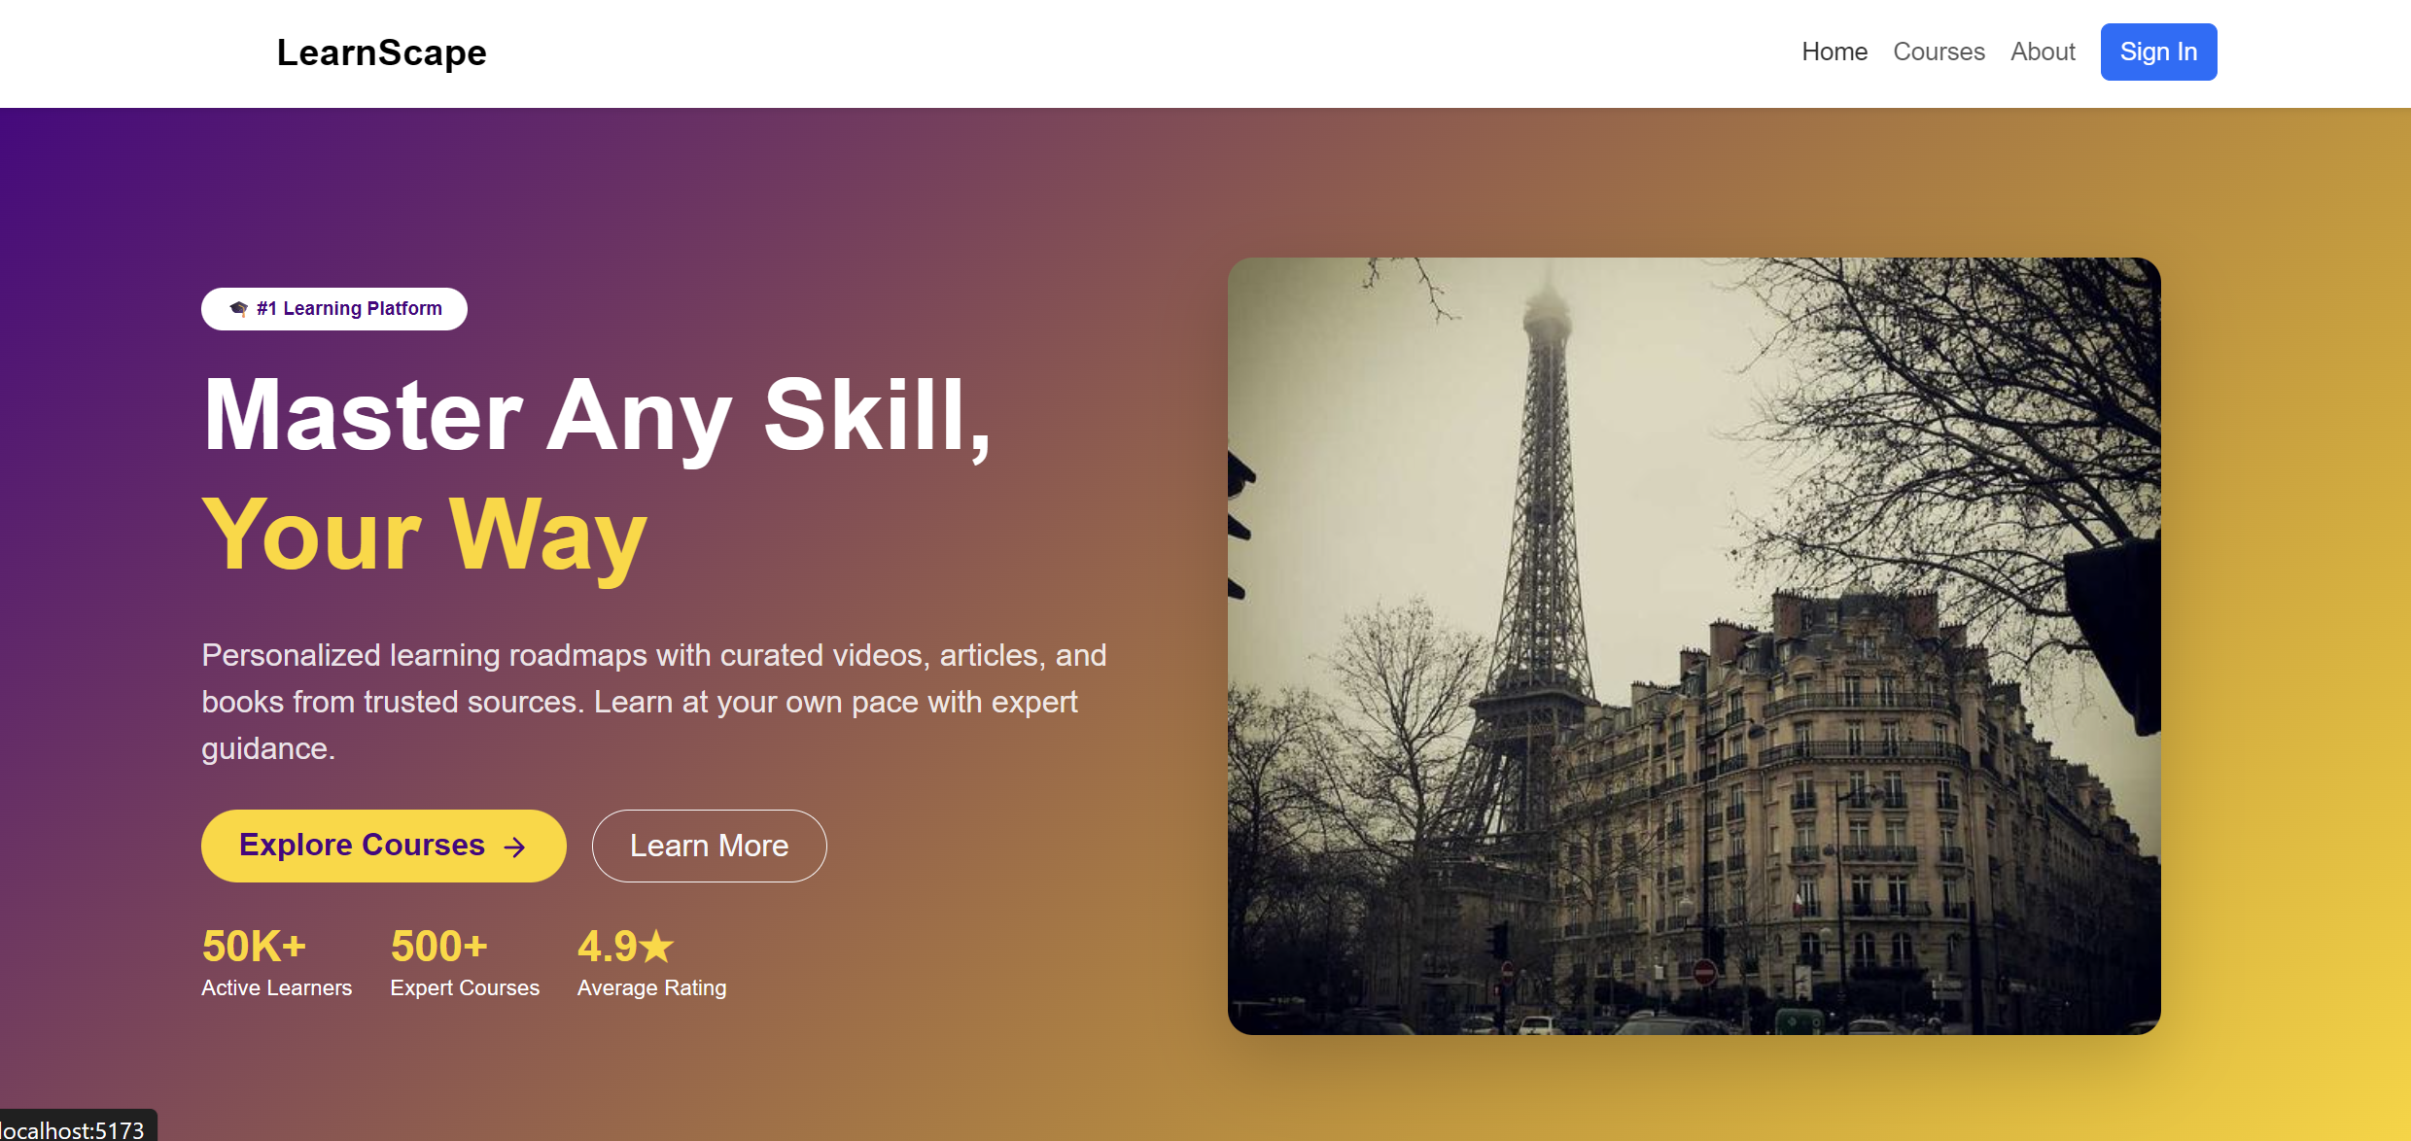

Conclusion:  
The implementation demonstrates React’s efficiency in creating interactive, reusable, and responsive web interfaces.

## Assignment 2: Home Page (Landing + Navbar)

Aim:  
To design and implement assignment 2: home page (landing + navbar) using React.js.

Theory:  
React.js provides a component-based architecture that simplifies the development of modern web applications. Each component manages its own state and renders efficiently when the underlying data changes. This modularity ensures better reusability, scalability, and maintainability of code. In this assignment, React concepts such as JSX, functional components, hooks (useState, useEffect), and props are utilized to achieve desired functionality.  
  
React promotes a declarative approach where the UI automatically updates when data changes. By leveraging Virtual DOM and efficient diffing algorithms, React minimizes DOM manipulation and improves performance. The assignment demonstrates how component-driven development enhances productivity and consistency across the LearnScape project.

Code:  
Sample code and component structure implemented using ReactJS.

Output:

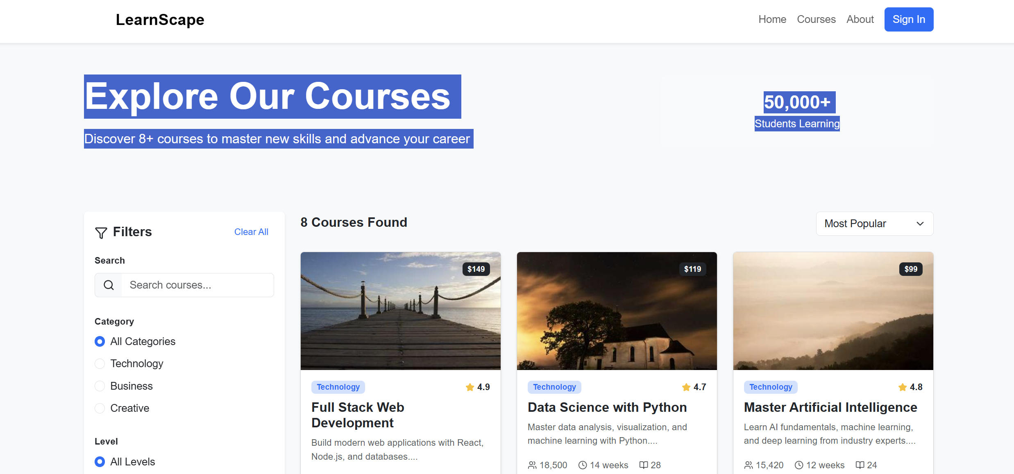

Conclusion:  
The implementation demonstrates React’s efficiency in creating interactive, reusable, and responsive web interfaces.

## Assignment 3: Courses / Learning Goals Page

Aim:  
To design and implement assignment 3: courses / learning goals page using React.js.

Theory:  
React.js provides a component-based architecture that simplifies the development of modern web applications. Each component manages its own state and renders efficiently when the underlying data changes. This modularity ensures better reusability, scalability, and maintainability of code. In this assignment, React concepts such as JSX, functional components, hooks (useState, useEffect), and props are utilized to achieve desired functionality.  
  
React promotes a declarative approach where the UI automatically updates when data changes. By leveraging Virtual DOM and efficient diffing algorithms, React minimizes DOM manipulation and improves performance. The assignment demonstrates how component-driven development enhances productivity and consistency across the LearnScape project.

Code:  
Sample code and component structure implemented using ReactJS.

Output:

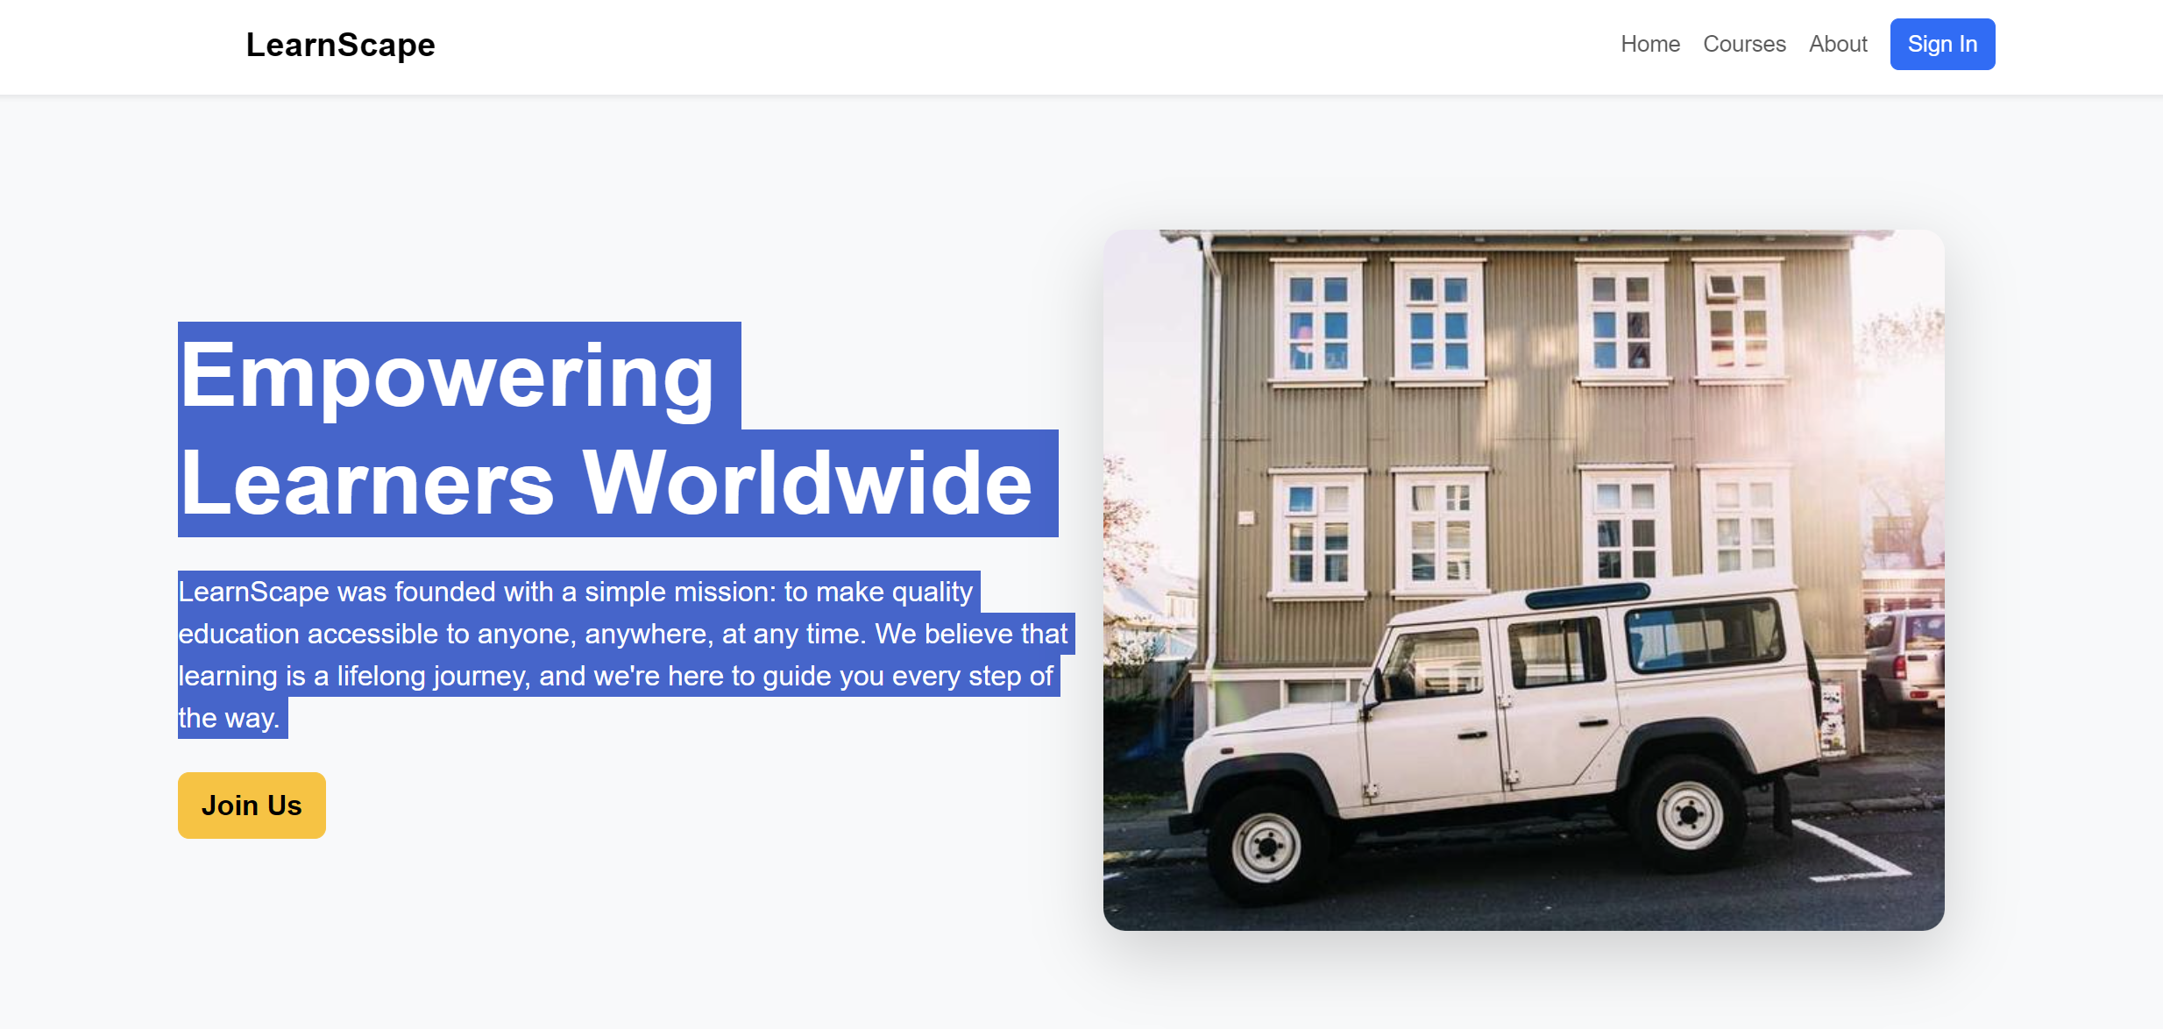

Conclusion:  
The implementation demonstrates React’s efficiency in creating interactive, reusable, and responsive web interfaces.

## Assignment 4: About / Get Started Section

Aim:  
To design and implement assignment 4: about / get started section using React.js.

Theory:  
React.js provides a component-based architecture that simplifies the development of modern web applications. Each component manages its own state and renders efficiently when the underlying data changes. This modularity ensures better reusability, scalability, and maintainability of code. In this assignment, React concepts such as JSX, functional components, hooks (useState, useEffect), and props are utilized to achieve desired functionality.  
  
React promotes a declarative approach where the UI automatically updates when data changes. By leveraging Virtual DOM and efficient diffing algorithms, React minimizes DOM manipulation and improves performance. The assignment demonstrates how component-driven development enhances productivity and consistency across the LearnScape project.

Code:  
Sample code and component structure implemented using ReactJS.

Output:

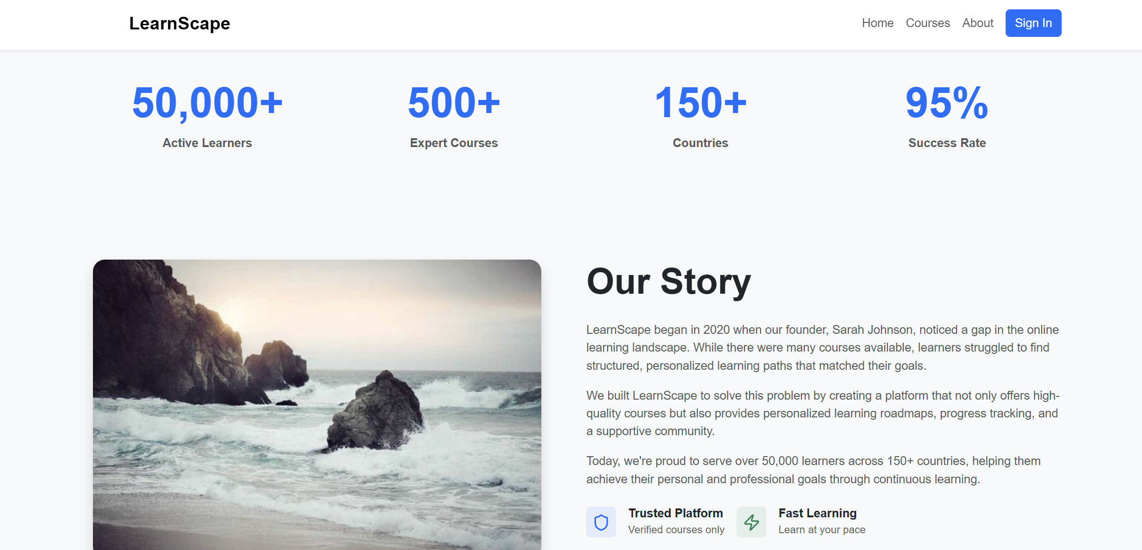

Conclusion:  
The implementation demonstrates React’s efficiency in creating interactive, reusable, and responsive web interfaces.

## Assignment 5: Roadmap or Resources Page

Aim:  
To design and implement assignment 5: roadmap or resources page using React.js.

Theory:  
React.js provides a component-based architecture that simplifies the development of modern web applications. Each component manages its own state and renders efficiently when the underlying data changes. This modularity ensures better reusability, scalability, and maintainability of code. In this assignment, React concepts such as JSX, functional components, hooks (useState, useEffect), and props are utilized to achieve desired functionality.  
  
React promotes a declarative approach where the UI automatically updates when data changes. By leveraging Virtual DOM and efficient diffing algorithms, React minimizes DOM manipulation and improves performance. The assignment demonstrates how component-driven development enhances productivity and consistency across the LearnScape project.

Code:  
Sample code and component structure implemented using ReactJS.

Output:

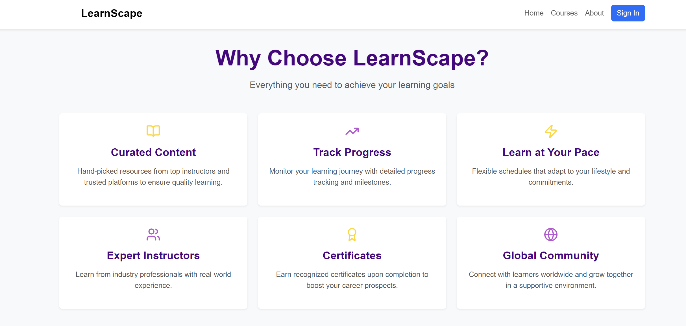

Conclusion:  
The implementation demonstrates React’s efficiency in creating interactive, reusable, and responsive web interfaces.

## Assignment 6: Sign In Page

Aim:  
To design and implement assignment 6: sign in page using React.js.

Theory:  
React.js provides a component-based architecture that simplifies the development of modern web applications. Each component manages its own state and renders efficiently when the underlying data changes. This modularity ensures better reusability, scalability, and maintainability of code. In this assignment, React concepts such as JSX, functional components, hooks (useState, useEffect), and props are utilized to achieve desired functionality.  
  
React promotes a declarative approach where the UI automatically updates when data changes. By leveraging Virtual DOM and efficient diffing algorithms, React minimizes DOM manipulation and improves performance. The assignment demonstrates how component-driven development enhances productivity and consistency across the LearnScape project.

Code:  
Sample code and component structure implemented using ReactJS.

Output:

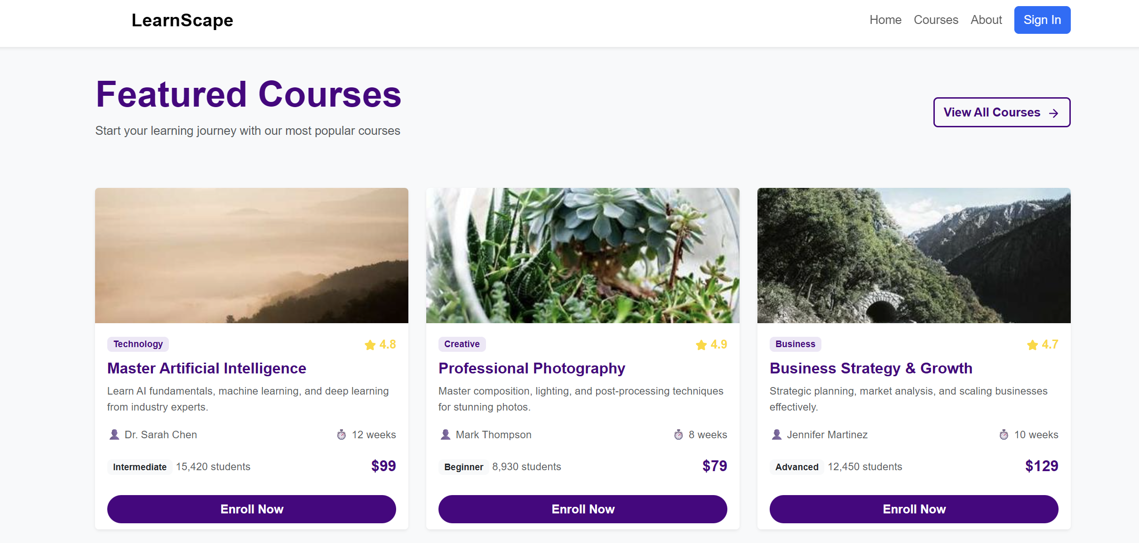

Conclusion:  
The implementation demonstrates React’s efficiency in creating interactive, reusable, and responsive web interfaces.

## Assignment 7: Sign Up / Create Account Page

Aim:  
To design and implement assignment 7: sign up / create account page using React.js.

Theory:  
React.js provides a component-based architecture that simplifies the development of modern web applications. Each component manages its own state and renders efficiently when the underlying data changes. This modularity ensures better reusability, scalability, and maintainability of code. In this assignment, React concepts such as JSX, functional components, hooks (useState, useEffect), and props are utilized to achieve desired functionality.  
  
React promotes a declarative approach where the UI automatically updates when data changes. By leveraging Virtual DOM and efficient diffing algorithms, React minimizes DOM manipulation and improves performance. The assignment demonstrates how component-driven development enhances productivity and consistency across the LearnScape project.

Code:  
Sample code and component structure implemented using ReactJS.

Output:

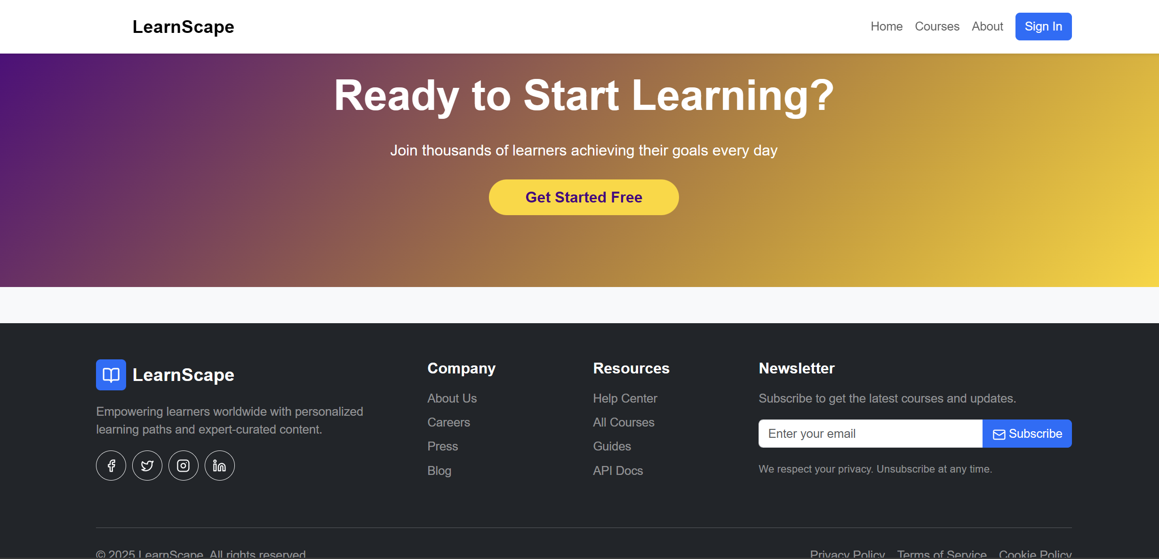

Conclusion:  
The implementation demonstrates React’s efficiency in creating interactive, reusable, and responsive web interfaces.

## Assignment 8: Responsive Design (Mobile Layout)

Aim:  
To design and implement assignment 8: responsive design (mobile layout) using React.js.

Theory:  
React.js provides a component-based architecture that simplifies the development of modern web applications. Each component manages its own state and renders efficiently when the underlying data changes. This modularity ensures better reusability, scalability, and maintainability of code. In this assignment, React concepts such as JSX, functional components, hooks (useState, useEffect), and props are utilized to achieve desired functionality.  
  
React promotes a declarative approach where the UI automatically updates when data changes. By leveraging Virtual DOM and efficient diffing algorithms, React minimizes DOM manipulation and improves performance. The assignment demonstrates how component-driven development enhances productivity and consistency across the LearnScape project.

Code:  
Sample code and component structure implemented using ReactJS.

Output:

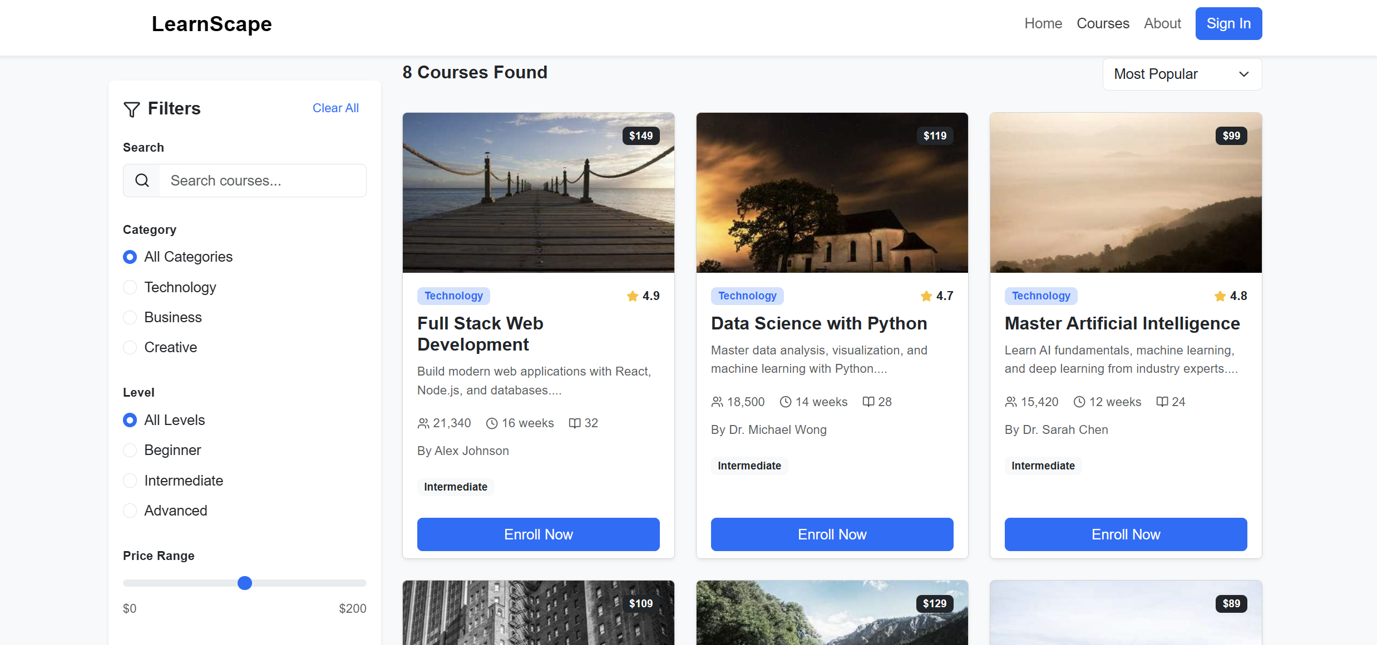

Conclusion:  
The implementation demonstrates React’s efficiency in creating interactive, reusable, and responsive web interfaces.

## Assignment 9: Profile / Dashboard Page

Aim:  
To design and implement assignment 9: profile / dashboard page using React.js.

Theory:  
React.js provides a component-based architecture that simplifies the development of modern web applications. Each component manages its own state and renders efficiently when the underlying data changes. This modularity ensures better reusability, scalability, and maintainability of code. In this assignment, React concepts such as JSX, functional components, hooks (useState, useEffect), and props are utilized to achieve desired functionality.  
  
React promotes a declarative approach where the UI automatically updates when data changes. By leveraging Virtual DOM and efficient diffing algorithms, React minimizes DOM manipulation and improves performance. The assignment demonstrates how component-driven development enhances productivity and consistency across the LearnScape project.

Code:  
Sample code and component structure implemented using ReactJS.

Output:

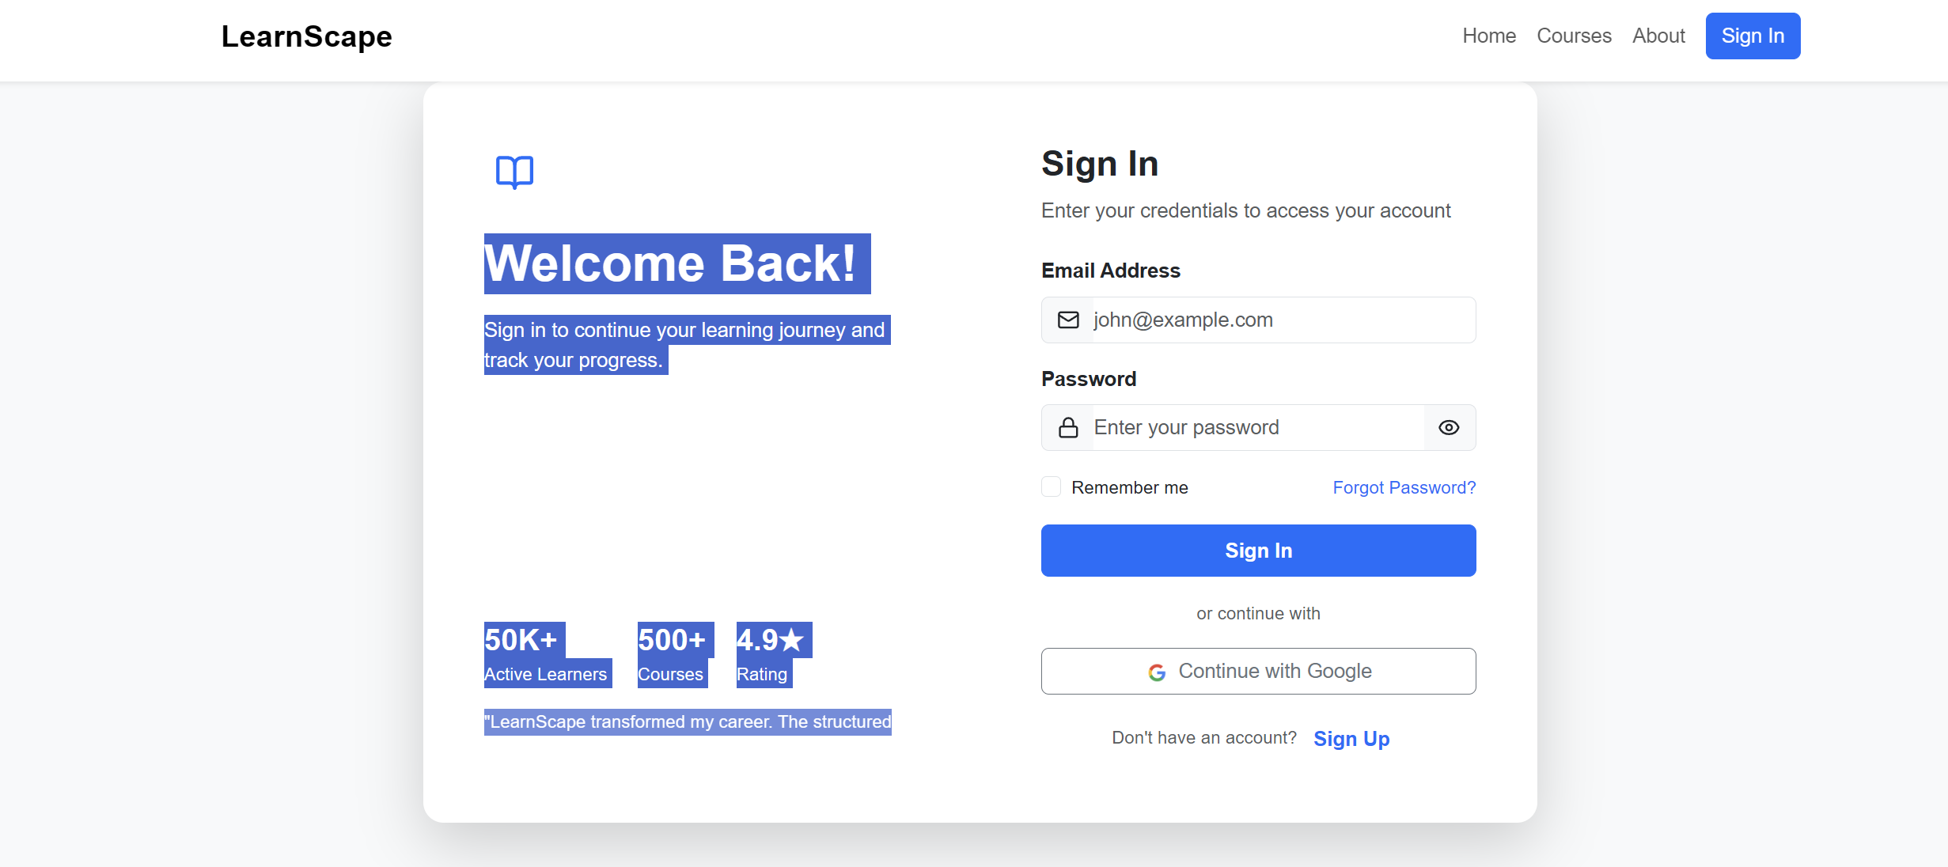

Conclusion:  
The implementation demonstrates React’s efficiency in creating interactive, reusable, and responsive web interfaces.

## Assignment 10: Full Website Overview

Aim:  
To design and implement assignment 10: full website overview using React.js.

Theory:  
React.js provides a component-based architecture that simplifies the development of modern web applications. Each component manages its own state and renders efficiently when the underlying data changes. This modularity ensures better reusability, scalability, and maintainability of code. In this assignment, React concepts such as JSX, functional components, hooks (useState, useEffect), and props are utilized to achieve desired functionality.  
  
React promotes a declarative approach where the UI automatically updates when data changes. By leveraging Virtual DOM and efficient diffing algorithms, React minimizes DOM manipulation and improves performance. The assignment demonstrates how component-driven development enhances productivity and consistency across the LearnScape project.

Code:  
Sample code and component structure implemented using ReactJS.

Output:

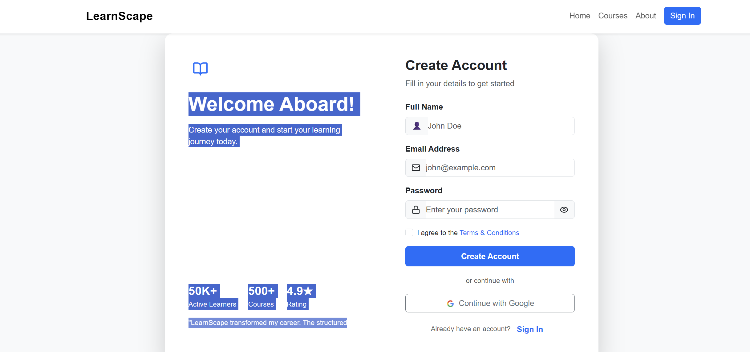

Conclusion:  
The implementation demonstrates React’s efficiency in creating interactive, reusable, and responsive web interfaces.

**Codes:**About.jsx

**// src/pages/About.jsx**

**import React from 'react';**

**import { Target, Users, Award, Globe, Heart, Zap, Shield, TrendingUp } from 'lucide-react';**

**const About = () => {**

**const teamMembers = [**

**{**

**name: 'Sarah Johnson',**

**role: 'CEO & Founder',**

**image: 'https://picsum.photos/seed/sarah/300/300',**

**bio: 'Former educator with 15+ years experience'**

**},**

**{**

**name: 'Michael Chen',**

**role: 'CTO',**

**image: 'https://picsum.photos/seed/michael/300/300',**

**bio: 'Tech innovator passionate about EdTech'**

**},**

**{**

**name: 'Emily Rodriguez',**

**role: 'Head of Content',**

**image: 'https://picsum.photos/seed/emily/300/300',**

**bio: 'Curriculum designer & learning strategist'**

**},**

**{**

**name: 'David Kim',**

**role: 'Head of Marketing',**

**image: 'https://picsum.photos/seed/david/300/300',**

**bio: 'Growth expert helping learners worldwide'**

**}**

**];**

**const values = [**

**{**

**icon: <Target size={32} />,**

**title: 'Mission-Driven',**

**description: 'Democratizing education and making quality learning accessible to everyone, everywhere.'**

**},**

**{**

**icon: <Users size={32} />,**

**title: 'Community First',**

**description: 'Building a supportive global community where learners help each other grow.'**

**},**

**{**

**icon: <Award size={32} />,**

**title: 'Excellence',**

**description: 'Curating only the highest quality content from verified experts and institutions.'**

**},**

**{**

**icon: <Heart size={32} />,**

**title: 'Passion for Learning',**

**description: 'We believe continuous learning is the key to personal and professional growth.'**

**}**

**];**

**const stats = [**

**{ number: '50,000+', label: 'Active Learners' },**

**{ number: '500+', label: 'Expert Courses' },**

**{ number: '150+', label: 'Countries' },**

**{ number: '95%', label: 'Success Rate' }**

**];**

**return (**

**<div>**

**{/* Hero Section */}**

**<section className="bg-gradient-primary text-white py-5">**

**<div className="container py-5">**

**<div className="row align-items-center">**

**<div className="col-lg-6 mb-4 mb-lg-0">**

**<h1 className="display-3 fw-bold mb-4">**

**Empowering Learners Worldwide**

**</h1>**

**<p className="lead mb-4">**

**LearnScape was founded with a simple mission: to make quality education accessible**

**to anyone, anywhere, at any time. We believe that learning is a lifelong journey,**

**and we're here to guide you every step of the way.**

**</p>**

**<div className="d-flex gap-3">**

**<button className="btn btn-warning btn-lg fw-semibold">Join Us</button>**

**<button className="btn btn-outline-light btn-lg">Contact Us</button>**

**</div>**

**</div>**

**<div className="col-lg-6">**

**<img**

**src="https://picsum.photos/seed/about/600/500"**

**alt="About Us"**

**className="img-fluid rounded-4 shadow-lg"**

**/>**

**</div>**

**</div>**

**</div>**

**</section>**

**{/* Stats Section */}**

**<section className="py-5 bg-light">**

**<div className="container">**

**<div className="row g-4">**

**{stats.map((stat, index) => (**

**<div key={index} className="col-md-3 col-sm-6">**

**<div className="text-center">**

**<h2 className="display-4 fw-bold text-primary mb-2">{stat.number}</h2>**

**<p className="text-muted fw-semibold mb-0">{stat.label}</p>**

**</div>**

**</div>**

**))}**

**</div>**

**</div>**

**</section>**

**{/* Our Story */}**

**<section className="py-5">**

**<div className="container py-5">**

**<div className="row">**

**<div className="col-lg-6 mb-4 mb-lg-0">**

**<img**

**src="https://picsum.photos/seed/story/600/400"**

**alt="Our Story"**

**className="img-fluid rounded-4 shadow"**

**/>**

**</div>**

**<div className="col-lg-6">**

**<h2 className="display-5 fw-bold mb-4">Our Story</h2>**

**<p className="text-muted mb-3">**

**LearnScape began in 2020 when our founder, Sarah Johnson, noticed a gap in the online**

**learning landscape. While there were many courses available, learners struggled to**

**find structured, personalized learning paths that matched their goals.**

**</p>**

**<p className="text-muted mb-3">**

**We built LearnScape to solve this problem by creating a platform that not only offers**

**high-quality courses but also provides personalized learning roadmaps, progress tracking,**

**and a supportive community.**

**</p>**

**<p className="text-muted mb-4">**

**Today, we're proud to serve over 50,000 learners across 150+ countries, helping them**

**achieve their personal and professional goals through continuous learning.**

**</p>**

**<div className="d-flex gap-3 flex-wrap">**

**<div className="d-flex align-items-center">**

**<div className="bg-primary bg-opacity-10 text-primary rounded p-2 me-3">**

**<Shield size={24} />**

**</div>**

**<div>**

**<h6 className="fw-bold mb-0">Trusted Platform</h6>**

**<small className="text-muted">Verified courses only</small>**

**</div>**

**</div>**

**<div className="d-flex align-items-center">**

**<div className="bg-success bg-opacity-10 text-success rounded p-2 me-3">**

**<Zap size={24} />**

**</div>**

**<div>**

**<h6 className="fw-bold mb-0">Fast Learning</h6>**

**<small className="text-muted">Learn at your pace</small>**

**</div>**

**</div>**

**</div>**

**</div>**

**</div>**

**</div>**

**</section>**

**{/* Our Values */}**

**<section className="py-5 bg-light">**

**<div className="container py-5">**

**<div className="text-center mb-5">**

**<h2 className="display-5 fw-bold mb-3">Our Values</h2>**

**<p className="lead text-muted">The principles that guide everything we do</p>**

**</div>**

**<div className="row g-4">**

**{values.map((value, index) => (**

**<div key={index} className="col-md-6 col-lg-3">**

**<div className="card border-0 shadow-sm h-100 hover-lift">**

**<div className="card-body p-4 text-center">**

**<div className="bg-primary bg-opacity-10 text-primary rounded-circle p-3 d-inline-flex mb-3">**

**{value.icon}**

**</div>**

**<h5 className="fw-bold mb-3">{value.title}</h5>**

**<p className="text-muted small mb-0">{value.description}</p>**

**</div>**

**</div>**

**</div>**

**))}**

**</div>**

**</div>**

**</section>**

**{/* Team Section */}**

**<section className="py-5">**

**<div className="container py-5">**

**<div className="text-center mb-5">**

**<h2 className="display-5 fw-bold mb-3">Meet Our Team</h2>**

**<p className="lead text-muted">Passionate educators and innovators dedicated to your success</p>**

**</div>**

**<div className="row g-4">**

**{teamMembers.map((member, index) => (**

**<div key={index} className="col-md-6 col-lg-3">**

**<div className="card border-0 shadow-sm h-100 hover-lift">**

**<img**

**src={member.image}**

**className="card-img-top"**

**alt={member.name}**

**style={{height: '300px', objectFit: 'cover'}}**

**/>**

**<div className="card-body text-center">**

**<h5 className="fw-bold mb-1">{member.name}</h5>**

**<p className="text-primary mb-2 small fw-semibold">{member.role}</p>**

**<p className="text-muted small mb-3">{member.bio}</p>**

**<div className="d-flex justify-content-center gap-2">**

**<a href="#" className="btn btn-sm btn-outline-primary rounded-circle" style={{width: '36px', height: '36px', padding: '8px'}}>**

**in**

**</a>**

**<a href="#" className="btn btn-sm btn-outline-primary rounded-circle" style={{width: '36px', height: '36px', padding: '8px'}}>**

**🐦**

**</a>**

**</div>**

**</div>**

**</div>**

**</div>**

**))}**

**</div>**

**</div>**

**</section>**

**{/* Testimonials */}**

**<section className="py-5 bg-light">**

**<div className="container py-5">**

**<div className="text-center mb-5">**

**<h2 className="display-5 fw-bold mb-3">What Our Learners Say</h2>**

**<p className="lead text-muted">Don't just take our word for it</p>**

**</div>**

**<div className="row g-4">**

**<div className="col-md-4">**

**<div className="card border-0 shadow-sm h-100">**

**<div className="card-body p-4">**

**<div className="mb-3">**

**<span className="text-warning">★★★★★</span>**

**</div>**

**<p className="mb-3">**

**"LearnScape completely transformed my career. The structured learning paths**

**and quality content helped me transition into tech in just 6 months!"**

**</p>**

**<div className="d-flex align-items-center">**

**<img**

**src="https://picsum.photos/seed/user1/50/50"**

**alt="User"**

**className="rounded-circle me-3"**

**style={{width: '50px', height: '50px'}}**

**/>**

**<div>**

**<h6 className="fw-bold mb-0">Jessica Martinez</h6>**

**<small className="text-muted">Software Developer</small>**

**</div>**

**</div>**

**</div>**

**</div>**

**</div>**

**<div className="col-md-4">**

**<div className="card border-0 shadow-sm h-100">**

**<div className="card-body p-4">**

**<div className="mb-3">**

**<span className="text-warning">★★★★★</span>**

**</div>**

**<p className="mb-3">**

**"The best investment I've made in myself. The progress tracking keeps me**

**motivated, and the community is incredibly supportive."**

**</p>**

**<div className="d-flex align-items-center">**

**<img**

**src="https://picsum.photos/seed/user2/50/50"**

**alt="User"**

**className="rounded-circle me-3"**

**style={{width: '50px', height: '50px'}}**

**/>**

**<div>**

**<h6 className="fw-bold mb-0">Alex Thompson</h6>**

**<small className="text-muted">Marketing Manager</small>**

**</div>**

**</div>**

**</div>**

**</div>**

**</div>**

**<div className="col-md-4">**

**<div className="card border-0 shadow-sm h-100">**

**<div className="card-body p-4">**

**<div className="mb-3">**

**<span className="text-warning">★★★★★</span>**

**</div>**

**<p className="mb-3">**

**"As a busy professional, I love that I can learn at my own pace.**

**The mobile app makes it easy to learn during my commute."**

**</p>**

**<div className="d-flex align-items-center">**

**<img**

**src="https://picsum.photos/seed/user3/50/50"**

**alt="User"**

**className="rounded-circle me-3"**

**style={{width: '50px', height: '50px'}}**

**/>**

**<div>**

**<h6 className="fw-bold mb-0">Priya Patel</h6>**

**<small className="text-muted">Business Analyst</small>**

**</div>**

**</div>**

**</div>**

**</div>**

**</div>**

**</div>**

**</div>**

**</section>**

**{/* CTA Section */}**

**<section className="py-5 bg-gradient-primary text-white">**

**<div className="container py-5 text-center">**

**<h2 className="display-4 fw-bold mb-4">Join Our Learning Community</h2>**

**<p className="lead mb-4">**

**Start your learning journey today and join thousands of learners achieving their goals**

**</p>**

**<button className="btn btn-warning btn-lg px-5 fw-semibold">**

**Get Started Free**

**</button>**

**</div>**

**</section>**

**</div>**

**);**

**};**

**export default About;**

**Cource.jsx:  
  
// src/pages/Courses.jsx**

**import React, { useState } from 'react';**

**import { Search, Filter, Star, Clock, Users, BookOpen, ChevronDown } from 'lucide-react';**

**import { coursesData } from '../data/coursesData';**

**const Courses = () => {**

**const [searchTerm, setSearchTerm] = useState('');**

**const [selectedCategory, setSelectedCategory] = useState('all');**

**const [selectedLevel, setSelectedLevel] = useState('all');**

**const [sortBy, setSortBy] = useState('popular');**

**const [showFilters, setShowFilters] = useState(false);**

**const categories = ['all', 'Technology', 'Business', 'Creative'];**

**const levels = ['all', 'Beginner', 'Intermediate', 'Advanced'];**

**// Filter courses**

**const filteredCourses = coursesData.filter(course => {**

**const matchesSearch = course.title.toLowerCase().includes(searchTerm.toLowerCase()) ||**

**course.description.toLowerCase().includes(searchTerm.toLowerCase());**

**const matchesCategory = selectedCategory === 'all' || course.category === selectedCategory;**

**const matchesLevel = selectedLevel === 'all' || course.level === selectedLevel;**

**return matchesSearch && matchesCategory && matchesLevel;**

**});**

**// Sort courses**

**const sortedCourses = [...filteredCourses].sort((a, b) => {**

**switch(sortBy) {**

**case 'popular':**

**return b.students - a.students;**

**case 'rating':**

**return b.rating - a.rating;**

**case 'price-low':**

**return a.price - b.price;**

**case 'price-high':**

**return b.price - a.price;**

**default:**

**return 0;**

**}**

**});**

**return (**

**<div className="bg-light min-vh-100">**

**{/* Header */}**

**<div className="bg-gradient-primary text-white py-5">**

**<div className="container">**

**<div className="row align-items-center">**

**<div className="col-lg-8">**

**<h1 className="display-4 fw-bold mb-3">Explore Our Courses</h1>**

**<p className="lead mb-0">**

**Discover {coursesData.length}+ courses to master new skills and advance your career**

**</p>**

**</div>**

**<div className="col-lg-4 mt-4 mt-lg-0">**

**<div className="bg-white bg-opacity-10 rounded-3 p-4 text-center">**

**<h3 className="fw-bold mb-1">50,000+</h3>**

**<p className="mb-0">Students Learning</p>**

**</div>**

**</div>**

**</div>**

**</div>**

**</div>**

**<div className="container py-5">**

**<div className="row">**

**{/* Filters Sidebar */}**

**<div className="col-lg-3 mb-4">**

**<div className="card border-0 shadow-sm sticky-top" style={{top: '100px'}}>**

**<div className="card-body">**

**<div className="d-flex justify-content-between align-items-center mb-3">**

**<h5 className="fw-bold mb-0">**

**<Filter size={20} className="me-2" />**

**Filters**

**</h5>**

**<button**

**className="btn btn-sm btn-link text-primary text-decoration-none"**

**onClick={() => {**

**setSelectedCategory('all');**

**setSelectedLevel('all');**

**setSearchTerm('');**

**}}**

**>**

**Clear All**

**</button>**

**</div>**

**{/* Search */}**

**<div className="mb-4">**

**<label className="form-label fw-semibold small">Search</label>**

**<div className="input-group">**

**<span className="input-group-text bg-light border-end-0">**

**<Search size={18} />**

**</span>**

**<input**

**type="text"**

**className="form-control border-start-0"**

**placeholder="Search courses..."**

**value={searchTerm}**

**onChange={(e) => setSearchTerm(e.target.value)}**

**/>**

**</div>**

**</div>**

**{/* Category Filter */}**

**<div className="mb-4">**

**<label className="form-label fw-semibold small">Category</label>**

**<div className="d-flex flex-column gap-2">**

**{categories.map(category => (**

**<div key={category} className="form-check">**

**<input**

**className="form-check-input"**

**type="radio"**

**name="category"**

**id={`cat-${category}`}**

**checked={selectedCategory === category}**

**onChange={() => setSelectedCategory(category)}**

**/>**

**<label className="form-check-label" htmlFor={`cat-${category}`}>**

**{category === 'all' ? 'All Categories' : category}**

**</label>**

**</div>**

**))}**

**</div>**

**</div>**

**{/* Level Filter */}**

**<div className="mb-4">**

**<label className="form-label fw-semibold small">Level</label>**

**<div className="d-flex flex-column gap-2">**

**{levels.map(level => (**

**<div key={level} className="form-check">**

**<input**

**className="form-check-input"**

**type="radio"**

**name="level"**

**id={`level-${level}`}**

**checked={selectedLevel === level}**

**onChange={() => setSelectedLevel(level)}**

**/>**

**<label className="form-check-label" htmlFor={`level-${level}`}>**

**{level === 'all' ? 'All Levels' : level}**

**</label>**

**</div>**

**))}**

**</div>**

**</div>**

**{/* Price Range */}**

**<div className="mb-4">**

**<label className="form-label fw-semibold small">Price Range</label>**

**<input**

**type="range"**

**className="form-range"**

**min="0"**

**max="200"**

**/>**

**<div className="d-flex justify-content-between small text-muted">**

**<span>$0</span>**

**<span>$200</span>**

**</div>**

**</div>**

**{/* Rating Filter */}**

**<div className="mb-4">**

**<label className="form-label fw-semibold small">Minimum Rating</label>**

**<div className="d-flex flex-column gap-2">**

**{[4.5, 4.0, 3.5, 3.0].map(rating => (**

**<div key={rating} className="form-check">**

**<input**

**className="form-check-input"**

**type="radio"**

**name="rating"**

**id={`rating-${rating}`}**

**/>**

**<label className="form-check-label d-flex align-items-center" htmlFor={`rating-${rating}`}>**

**<Star size={14} fill="#fbbf24" className="text-warning me-1" />**

**{rating} & up**

**</label>**

**</div>**

**))}**

**</div>**

**</div>**

**</div>**

**</div>**

**</div>**

**{/* Courses Grid */}**

**<div className="col-lg-9">**

**{/* Sort Bar */}**

**<div className="d-flex justify-content-between align-items-center mb-4">**

**<div>**

**<h5 className="fw-bold mb-1">**

**{sortedCourses.length} {sortedCourses.length === 1 ? 'Course' : 'Courses'} Found**

**</h5>**

**<p className="text-muted small mb-0">**

**{searchTerm && `Showing results for "${searchTerm}"`}**

**</p>**

**</div>**

**<select**

**className="form-select w-auto"**

**value={sortBy}**

**onChange={(e) => setSortBy(e.target.value)}**

**>**

**<option value="popular">Most Popular</option>**

**<option value="rating">Highest Rated</option>**

**<option value="price-low">Price: Low to High</option>**

**<option value="price-high">Price: High to Low</option>**

**</select>**

**</div>**

**{/* Courses */}**

**{sortedCourses.length > 0 ? (**

**<div className="row g-4">**

**{sortedCourses.map(course => (**

**<div key={course.id} className="col-md-6 col-xl-4">**

**<div className="card course-card shadow-sm h-100">**

**<div className="position-relative">**

**<img**

**src={course.image}**

**className="card-img-top"**

**alt={course.title}**

**/>**

**<span className="position-absolute top-0 end-0 m-3 badge bg-dark">**

**${course.price}**

**</span>**

**</div>**

**<div className="card-body">**

**<div className="d-flex justify-content-between align-items-center mb-2">**

**<span className="badge bg-primary-subtle text-primary">**

**{course.category}**

**</span>**

**<div className="d-flex align-items-center">**

**<Star size={14} fill="#fbbf24" className="text-warning me-1" />**

**<span className="fw-bold small">{course.rating}</span>**

**</div>**

**</div>**

**<h5 className="card-title fw-bold mb-2">{course.title}</h5>**

**<p className="card-text text-muted small mb-3">**

**{course.description.substring(0, 90)}...**

**</p>**

**<div className="d-flex align-items-center text-muted small mb-2">**

**<Users size={14} className="me-1" />**

**<span className="me-3">{course.students.toLocaleString()}</span>**

**<Clock size={14} className="me-1" />**

**<span className="me-3">{course.duration}</span>**

**<BookOpen size={14} className="me-1" />**

**<span>{course.resources}</span>**

**</div>**

**<div className="mb-3">**

**<small className="text-muted">By {course.instructor}</small>**

**</div>**

**<span className="badge bg-light text-dark">{course.level}</span>**

**</div>**

**<div className="card-footer bg-white border-0">**

**<button className="btn btn-primary w-100">**

**Enroll Now**

**</button>**

**</div>**

**</div>**

**</div>**

**))}**

**</div>**

**) : (**

**<div className="text-center py-5">**

**<BookOpen size={64} className="text-muted mb-3" />**

**<h4 className="fw-bold mb-2">No courses found</h4>**

**<p className="text-muted">**

**Try adjusting your filters or search terms**

**</p>**

**<button**

**className="btn btn-primary"**

**onClick={() => {**

**setSearchTerm('');**

**setSelectedCategory('all');**

**setSelectedLevel('all');**

**}}**

**>**

**Clear Filters**

**</button>**

**</div>**

**)}**

**{/* Pagination */}**

**{sortedCourses.length > 0 && (**

**<nav className="mt-5">**

**<ul className="pagination justify-content-center">**

**<li className="page-item disabled">**

**<a className="page-link">Previous</a>**

**</li>**

**<li className="page-item active"><a className="page-link" href="#">1</a></li>**

**<li className="page-item"><a className="page-link" href="#">2</a></li>**

**<li className="page-item"><a className="page-link" href="#">3</a></li>**

**<li className="page-item">**

**<a className="page-link" href="#">Next</a>**

**</li>**

**</ul>**

**</nav>**

**)}**

**</div>**

**</div>**

**</div>**

**</div>**

**);**

**};**

**export default Courses;**

**Dashboard.jsx:  
  
// src/pages/Dashboard.jsx**

**import React, { useState } from 'react';**

**import { Link } from 'react-router-dom';**

**import { BookOpen, Clock, Award, TrendingUp, Target, Calendar, Play, Star, Filter } from 'lucide-react';**

**import { coursesData, myJourneyData, userStats } from '../data/coursesData';**

**const Dashboard = ({ userName }) => {**

**const [enrolledCourses, setEnrolledCourses] = useState(myJourneyData);**

**const [selectedCategory, setSelectedCategory] = useState('all');**

**const categories = ['all', 'Technology', 'Business', 'Creative'];**

**const availableCourses = coursesData.filter(**

**course => !enrolledCourses.find(enrolled => enrolled.courseId === course.id)**

**);**

**const handleEnrollCourse = (course) => {**

**const newEnrollment = {**

**id: enrolledCourses.length + 1,**

**courseId: course.id,**

**title: course.title,**

**progress: 0,**

**completedLessons: 0,**

**totalLessons: course.resources,**

**lastAccessed: 'Just now',**

**nextLesson: `${course.title} - Introduction`,**

**image: course.image,**

**timeSpent: '0 hours',**

**category: course.category**

**};**

**setEnrolledCourses([...enrolledCourses, newEnrollment]);**

**};**

**const filteredAvailableCourses = selectedCategory === 'all'**

**? availableCourses**

**: availableCourses.filter(course => course.category === selectedCategory);**

**return (**

**<div className="container my-5">**

**{/* Welcome Section */}**

**<div className="row mb-4">**

**<div className="col-12">**

**<div className="bg-gradient-primary text-white rounded-4 p-4 p-md-5 shadow-sm">**

**<div className="row align-items-center">**

**<div className="col-md-8">**

**<h2 className="display-6 fw-bold mb-2">Welcome back, {userName || 'Learner'}! 👋</h2>**

**<p className="mb-0 opacity-75">**

**You're making great progress. Keep up the momentum and achieve your learning goals!**

**</p>**

**</div>**

**<div className="col-md-4 text-md-end mt-3 mt-md-0">**

**<Link to="/my-journey" className="btn btn-warning btn-lg fw-semibold">**

**Continue Learning**

**</Link>**

**</div>**

**</div>**

**</div>**

**</div>**

**</div>**

**{/* Stats Cards */}**

**<div className="row g-4 mb-5">**

**<div className="col-md-3 col-sm-6">**

**<div className="stats-card">**

**<div className="d-flex align-items-center justify-content-between mb-3">**

**<div className="bg-primary bg-opacity-10 text-primary rounded p-3">**

**<BookOpen size={24} />**

**</div>**

**<span className="text-muted small">Total</span>**

**</div>**

**<h3 className="fw-bold mb-1">{enrolledCourses.length}</h3>**

**<p className="text-muted mb-0 small">Enrolled Courses</p>**

**</div>**

**</div>**

**<div className="col-md-3 col-sm-6">**

**<div className="stats-card" style={{borderLeftColor: '#10b981'}}>**

**<div className="d-flex align-items-center justify-content-between mb-3">**

**<div className="bg-success bg-opacity-10 text-success rounded p-3">**

**<Award size={24} />**

**</div>**

**<span className="text-muted small">Earned</span>**

**</div>**

**<h3 className="fw-bold mb-1">{userStats.certificates}</h3>**

**<p className="text-muted mb-0 small">Certificates</p>**

**</div>**

**</div>**

**<div className="col-md-3 col-sm-6">**

**<div className="stats-card" style={{borderLeftColor: '#f59e0b'}}>**

**<div className="d-flex align-items-center justify-content-between mb-3">**

**<div className="bg-warning bg-opacity-10 text-warning rounded p-3">**

**<Clock size={24} />**

**</div>**

**<span className="text-muted small">This month</span>**

**</div>**

**<h3 className="fw-bold mb-1">{userStats.totalHours}h</h3>**

**<p className="text-muted mb-0 small">Learning Time</p>**

**</div>**

**</div>**

**<div className="col-md-3 col-sm-6">**

**<div className="stats-card" style={{borderLeftColor: '#ef4444'}}>**

**<div className="d-flex align-items-center justify-content-between mb-3">**

**<div className="bg-danger bg-opacity-10 text-danger rounded p-3">**

**<Target size={24} />**

**</div>**

**<span className="text-muted small">Current</span>**

**</div>**

**<h3 className="fw-bold mb-1">{userStats.streak} days</h3>**

**<p className="text-muted mb-0 small">Learning Streak 🔥</p>**

**</div>**

**</div>**

**</div>**

**{/* My Enrolled Courses */}**

**<div className="mb-5">**

**<div className="d-flex justify-content-between align-items-center mb-4">**

**<div>**

**<h3 className="fw-bold mb-1">My Learning Goals</h3>**

**<p className="text-muted mb-0">Continue where you left off</p>**

**</div>**

**<Link to="/my-journey" className="btn btn-outline-primary">**

**View All**

**</Link>**

**</div>**

**{enrolledCourses.length > 0 ? (**

**<div className="row g-4">**

**{enrolledCourses.map((course) => (**

**<div key={course.id} className="col-md-6 col-lg-4">**

**<div className="card course-card shadow-sm h-100">**

**<div className="position-relative">**

**<img**

**src={course.image}**

**className="card-img-top"**

**alt={course.title}**

**style={{height: '180px', objectFit: 'cover'}}**

**/>**

**<div className="position-absolute top-0 end-0 m-3">**

**<span className="badge bg-primary">{course.progress}% Complete</span>**

**</div>**

**</div>**

**<div className="card-body">**

**<span className="badge bg-light text-dark mb-2">{course.category}</span>**

**<h5 className="card-title fw-bold mb-2">{course.title}</h5>**

**<div className="mb-3">**

**<div className="progress progress-custom mb-2">**

**<div**

**className="progress-bar progress-bar-custom"**

**style={{width: `${course.progress}%`}}**

**></div>**

**</div>**

**<div className="d-flex justify-content-between text-muted small">**

**<span>{course.completedLessons}/{course.totalLessons} lessons</span>**

**<span>{course.timeSpent}</span>**

**</div>**

**</div>**

**<div className="d-flex gap-2">**

**<Link to="/my-journey" className="btn btn-primary flex-grow-1">**

**<Play size={16} className="me-1" />**

**Continue**

**</Link>**

**<button className="btn btn-outline-secondary">**

**<Calendar size={16} />**

**</button>**

**</div>**

**</div>**

**<div className="card-footer bg-light border-0">**

**<small className="text-muted">**

**Last accessed: {course.lastAccessed}**

**</small>**

**</div>**

**</div>**

**</div>**

**))}**

**</div>**

**) : (**

**<div className="text-center py-5 bg-light rounded-4">**

**<BookOpen size={48} className="text-muted mb-3" />**

**<h5 className="fw-bold mb-2">No courses enrolled yet</h5>**

**<p className="text-muted mb-3">Start your learning journey by enrolling in a course below</p>**

**</div>**

**)}**

**</div>**

**{/* Available Courses to Enroll */}**

**<div className="mb-5">**

**<div className="d-flex justify-content-between align-items-center mb-4">**

**<div>**

**<h3 className="fw-bold mb-1">Discover More Courses</h3>**

**<p className="text-muted mb-0">Expand your skills with these courses</p>**

**</div>**

**<div className="d-flex gap-2 align-items-center">**

**<Filter size={18} className="text-muted" />**

**<select**

**className="form-select form-select-sm"**

**style={{width: 'auto'}}**

**value={selectedCategory}**

**onChange={(e) => setSelectedCategory(e.target.value)}**

**>**

**{categories.map(cat => (**

**<option key={cat} value={cat}>**

**{cat === 'all' ? 'All Categories' : cat}**

**</option>**

**))}**

**</select>**

**</div>**

**</div>**

**<div className="row g-4">**

**{filteredAvailableCourses.slice(0, 6).map((course) => (**

**<div key={course.id} className="col-md-6 col-lg-4">**

**<div className="card course-card shadow-sm h-100">**

**<img**

**src={course.image}**

**className="card-img-top"**

**alt={course.title}**

**/>**

**<div className="card-body">**

**<div className="d-flex justify-content-between align-items-center mb-2">**

**<span className="badge bg-primary-subtle text-primary">{course.category}</span>**

**<span className="text-warning fw-bold small">**

**<Star size={14} fill="currentColor" /> {course.rating}**

**</span>**

**</div>**

**<h5 className="card-title fw-bold mb-2">{course.title}</h5>**

**<p className="card-text text-muted small mb-3">**

**{course.description.substring(0, 80)}...**

**</p>**

**<div className="d-flex justify-content-between align-items-center text-muted small mb-3">**

**<span>👤 {course.instructor}</span>**

**<span>⏱️ {course.duration}</span>**

**</div>**

**<div className="d-flex justify-content-between align-items-center">**

**<span className="badge bg-light text-dark">{course.level}</span>**

**<span className="fw-bold text-primary">${course.price}</span>**

**</div>**

**</div>**

**<div className="card-footer bg-white border-0">**

**<button**

**className="btn btn-outline-primary w-100"**

**onClick={() => handleEnrollCourse(course)}**

**>**

**Enroll Now**

**</button>**

**</div>**

**</div>**

**</div>**

**))}**

**</div>**

**<div className="text-center mt-4">**

**<Link to="/courses" className="btn btn-primary btn-lg">**

**Browse All Courses**

**</Link>**

**</div>**

**</div>**

**</div>**

**);**

**};**

**export default Dashboard;**

**Home.jsx:  
  
// src/pages/Home.jsx**

**import React from 'react';**

**import { Link } from 'react-router-dom';**

**import { BookOpen, Video, Users, Award, Zap, Shield, Globe, TrendingUp, Star, ArrowRight } from 'lucide-react';**

**import { coursesData } from '../data/coursesData';**

**const Home = () => {**

**const featuredCourses = coursesData.slice(0, 3);**

**return (**

**<div>**

**{/* Hero Section */}**

**<section**

**className="hero-section py-5"**

**style={{**

**background: 'linear-gradient(135deg, #4B0082, #FFD700)',**

**color: 'white',**

**}}**

**>**

**<div className="container py-5">**

**<div className="row align-items-center">**

**<div className="col-lg-6 mb-4 mb-lg-0">**

**<span**

**className="badge px-3 py-2 rounded-pill mb-3"**

**style={{**

**backgroundColor: 'white',**

**color: '#4B0082',**

**fontWeight: '600',**

**}}**

**>**

**🎓 #1 Learning Platform**

**</span>**

**<h1 className="display-3 fw-bold mb-4">**

**Master Any Skill, <br />**

**<span style={{ color: '#FFD700' }}>Your Way</span>**

**</h1>**

**<p className="lead mb-4" style={{ color: 'rgba(255,255,255,0.85)' }}>**

**Personalized learning roadmaps with curated videos, articles, and books from trusted sources.**

**Learn at your own pace with expert guidance.**

**</p>**

**<div className="d-flex gap-3 flex-wrap mb-4">**

**<Link**

**to="/courses"**

**className="btn btn-lg px-4 fw-bold"**

**style={{**

**backgroundColor: '#FFD700',**

**color: '#4B0082',**

**borderRadius: '30px',**

**border: 'none',**

**}}**

**>**

**Explore Courses**

**<ArrowRight size={20} className="ms-2" />**

**</Link>**

**<Link**

**to="/about"**

**className="btn btn-outline-light btn-lg px-4"**

**style={{ borderRadius: '30px' }}**

**>**

**Learn More**

**</Link>**

**</div>**

**{/* Stats */}**

**<div className="d-flex gap-4 mt-4 flex-wrap">**

**<div>**

**<h3 className="fw-bold mb-0" style={{ color: '#FFD700' }}>50K+</h3>**

**<p className="mb-0 small">Active Learners</p>**

**</div>**

**<div>**

**<h3 className="fw-bold mb-0" style={{ color: '#FFD700' }}>500+</h3>**

**<p className="mb-0 small">Expert Courses</p>**

**</div>**

**<div>**

**<h3 className="fw-bold mb-0" style={{ color: '#FFD700' }}>4.9★</h3>**

**<p className="mb-0 small">Average Rating</p>**

**</div>**

**</div>**

**</div>**

**<div className="col-lg-6">**

**<img**

**src="https://picsum.photos/seed/hero/600/500"**

**alt="Learning"**

**className="img-fluid rounded-4 shadow-lg"**

**/>**

**</div>**

**</div>**

**</div>**

**</section>**

**{/* Features Section */}**

**<section className="py-5 bg-light">**

**<div className="container py-5">**

**<div className="text-center mb-5">**

**<h2 className="display-5 fw-bold mb-3" style={{ color: '#4B0082' }}>**

**Why Choose LearnScape?**

**</h2>**

**<p className="lead text-muted">**

**Everything you need to achieve your learning goals**

**</p>**

**</div>**

**<div className="row g-4">**

**{[**

**{ icon: <BookOpen size={32} color="#FFD700" />, title: 'Curated Content', desc: 'Hand-picked resources from top instructors and trusted platforms to ensure quality learning.' },**

**{ icon: <TrendingUp size={32} color="#BA55D3" />, title: 'Track Progress', desc: 'Monitor your learning journey with detailed progress tracking and milestones.' },**

**{ icon: <Zap size={32} color="#FFD700" />, title: 'Learn at Your Pace', desc: 'Flexible schedules that adapt to your lifestyle and commitments.' },**

**{ icon: <Users size={32} color="#BA55D3" />, title: 'Expert Instructors', desc: 'Learn from industry professionals with real-world experience.' },**

**{ icon: <Award size={32} color="#FFD700" />, title: 'Certificates', desc: 'Earn recognized certificates upon completion to boost your career prospects.' },**

**{ icon: <Globe size={32} color="#BA55D3" />, title: 'Global Community', desc: 'Connect with learners worldwide and grow together in a supportive environment.' },**

**].map((feature, index) => (**

**<div className="col-md-4" key={index}>**

**<div**

**className="card border-0 shadow-sm h-100 text-center hover-lift"**

**style={{**

**backgroundColor: 'white',**

**borderTop: `4px solid ${index % 2 === 0 ? '#FFD700' : '#BA55D3'}`,**

**}}**

**>**

**<div className="card-body p-4">**

**<div className="mb-3">{feature.icon}</div>**

**<h4 className="fw-bold mb-3" style={{ color: '#4B0082' }}>**

**{feature.title}**

**</h4>**

**<p className="text-muted">{feature.desc}</p>**

**</div>**

**</div>**

**</div>**

**))}**

**</div>**

**</div>**

**</section>**

**{/* Featured Courses Section */}**

**<section className="py-5">**

**<div className="container py-5">**

**<div className="d-flex justify-content-between align-items-center mb-5">**

**<div>**

**<h2 className="display-5 fw-bold mb-2" style={{ color: '#4B0082' }}>**

**Featured Courses**

**</h2>**

**<p className="text-muted">**

**Start your learning journey with our most popular courses**

**</p>**

**</div>**

**<Link**

**to="/courses"**

**className="btn btn-outline"**

**style={{**

**color: '#4B0082',**

**border: '2px solid #4B0082',**

**fontWeight: '600',**

**}}**

**>**

**View All Courses**

**<ArrowRight size={18} className="ms-2" />**

**</Link>**

**</div>**

**<div className="row g-4">**

**{featuredCourses.map((course) => (**

**<div key={course.id} className="col-md-4">**

**<div className="card shadow-sm h-100 border-0">**

**<img**

**src={course.image}**

**className="card-img-top"**

**alt={course.title}**

**/>**

**<div className="card-body">**

**<div className="d-flex justify-content-between align-items-center mb-2">**

**<span**

**className="badge"**

**style={{**

**backgroundColor: '#EDE7F6',**

**color: '#4B0082',**

**}}**

**>**

**{course.category}**

**</span>**

**<span className="fw-bold" style={{ color: '#FFD700' }}>**

**<Star size={16} fill="currentColor" /> {course.rating}**

**</span>**

**</div>**

**<h5 className="card-title fw-bold mb-2" style={{ color: '#4B0082' }}>**

**{course.title}**

**</h5>**

**<p className="card-text text-muted small mb-3">**

**{course.description}**

**</p>**

**<div className="d-flex justify-content-between align-items-center text-muted small mb-3">**

**<span>👤 {course.instructor}</span>**

**<span>⏱️ {course.duration}</span>**

**</div>**

**<div className="d-flex justify-content-between align-items-center">**

**<div>**

**<span className="badge bg-light text-dark me-1">{course.level}</span>**

**<span className="text-muted small">**

**{course.students.toLocaleString()} students**

**</span>**

**</div>**

**<span className="fw-bold fs-5" style={{ color: '#4B0082' }}>**

**${course.price}**

**</span>**

**</div>**

**</div>**

**<div className="card-footer bg-white border-0">**

**<Link**

**to="/courses"**

**className="btn w-100 fw-bold"**

**style={{**

**backgroundColor: '#4B0082',**

**color: 'white',**

**borderRadius: '25px',**

**}}**

**>**

**Enroll Now**

**</Link>**

**</div>**

**</div>**

**</div>**

**))}**

**</div>**

**</div>**

**</section>**

**{/* CTA Section */}**

**<section**

**className="py-5 text-white text-center"**

**style={{**

**background: 'linear-gradient(135deg, #4B0082, #FFD700)',**

**}}**

**>**

**<div className="container py-5">**

**<h2 className="display-4 fw-bold mb-4">Ready to Start Learning?</h2>**

**<p className="lead mb-4">Join thousands of learners achieving their goals every day</p>**

**<Link**

**to="/login"**

**className="btn btn-lg px-5 fw-bold"**

**style={{**

**backgroundColor: '#FFD700',**

**color: '#4B0082',**

**borderRadius: '30px',**

**}}**

**>**

**Get Started Free**

**</Link>**

**</div>**

**</section>**

**</div>**

**);**

**};**

**export default Home;**